Press Contact: Ginny Robinson
(707) 206-8911
ginny@chandracerrito.com
www.chandracerritocontemporary.com
FOR IMMEDIATE RELEASE

Sheila Ghidini: Conversations
August 2nd – September 26th, 2013
Opening Reception: Friday, August 2nd, 6 – 8 pm
Artist Talk moderated by Anthony Pinata from Oakland Museum of California
Saturday, August 10th, 2 – 3 pm
Second First Friday Reception: Friday September 6, 6 - 8 pm

Oakland, CA Chandra Cerrito Contemporary is pleased to announce a solo exhibition by Sheila Ghidini. Sheila Ghidini’s ongoing fascination with chairs as a means to embody both presence and absence is displayed in her most recent works exhibited in Conversations. An empty chair can imply the prior presence, and therefore absence, of a human inhabitant, while it can also act as a stand-in for the human figure. Ghidini’s current exhibition features a series of graphite drawings depicting individual chairs or groups of them as well as two sculptural works made from found chairs that have been altered.
Ghidini’s delicately rendered portraits of individual chairs, each with their own particular details, exhibit her love of close observation and her masterful technical abilities. While these renderings of single chairs are like character studies, drawings of multiple chairs reference the psychology of group dynamics. Disrupting a sense of communion among gathered chairs, Ghidini deliberately disturbs traditional spatial perspective. While traditional linear perspective calls for only one or two vanishing points, Ghidini assigns each chair, each figure, its own slightly different point of view. A scene that at first appears to be the remnants of a collective seems instead to be evidence of individual isolation within shared space.

Chairs are metaphors in Ghidini’s two sculptural works. In Reflection, a chair with two backs facing one another is created from reassembled wood chairs painted white. Like Narcissus, the figure caught in self-reflection is rendered useless. Murmuration is a dreamlike installation featuring a white wood chair with absurdly tall legs that is placed against the wall. A lacey graphite drawing covers parts of the wall and back of the chair, depicting birds in dynamic swarm formations. In this case, the chair is a figure whose firmly grounded nature is overcome so that it may also reach the celestial sphere.

About the Artist: Sheila Ghidini earned her BFA from Hartford Art School at the University of Hartford, West Hartford, CT (1974), completed graduate studies at Cranbrook Academy of Art in Bloomfield Hills, MI (1979) and earned her MFA at UC Berkeley (1992). Her work has been exhibited at Hunter College in New York City, San Francisco’s Museo ItaloAmericano, the Jewish Museum in San Francisco and the Maier Museum of Art in Lynchburg, VA. This is her fifth exhibition at Chandra Cerrito Contemporary.

About Chandra Cerrito Contemporary: Established in 2007 as a curatorial project space, Chandra Cerrito Contemporary features exhibitions and site-specific installations that highlight exceptional regional and national artists, with an emphasis on conceptual strength, refined craftsmanship, contemporary vision and art historical relevance.

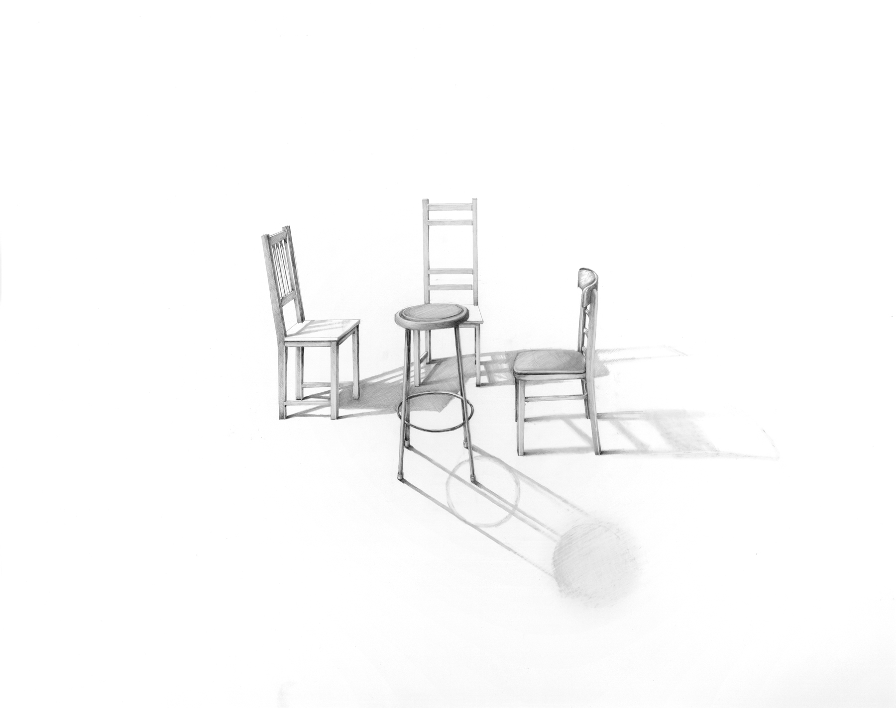

Sheila Ghidini
Conversation 10, 2013
graphite on paper
23 x 29 inches
Courtesy of Chandra Cerrito Contemporary

Chandra Cerrito Contemporary
480 23rd Street Oakland, CA
www.chandracerritocontemporary.com
chandra@chandracerrito.com

Hours: Thursday – Saturday 12 – 6 PM, First Fridays until 8 PM, and by appointment
Free and open to the public
High-resolution images are available by contacting Ginny Robinson
(707) 206-8911, ginny@chandracerrito.com

# # #

